Project Design Phase-II
Data Flow Diagram & User Stories
Date | 12 October 2026
Team ID | SWUID2026403326
Project Name | IMovies – Online Movie, Event & Entertainment Ticket Booking System
Maximum Marks | 4 Marks
Data Flow Diagrams:
A Data Flow Diagram (DFD) illustrates how data moves within the IMovies ticket booking platform. It shows how users (customers, cinema managers, event organizers and admins) and external systems (mock payment gateway and SMTP email server) interact with the system, how information flows between processes, and where the data is stored. The diagrams below follow the SRS and are drawn at two levels: Level 0 (context) and Level 1 (major processes).
Legend:
Symbol | Meaning
Rectangle | External entity (user or external system)
Circle | Process that transforms data
Open-ended bar (D1–D9) | Data store (database table group)
Arrow | Data flow, labelled with the data moved

DFD Level 0 – Context Diagram:
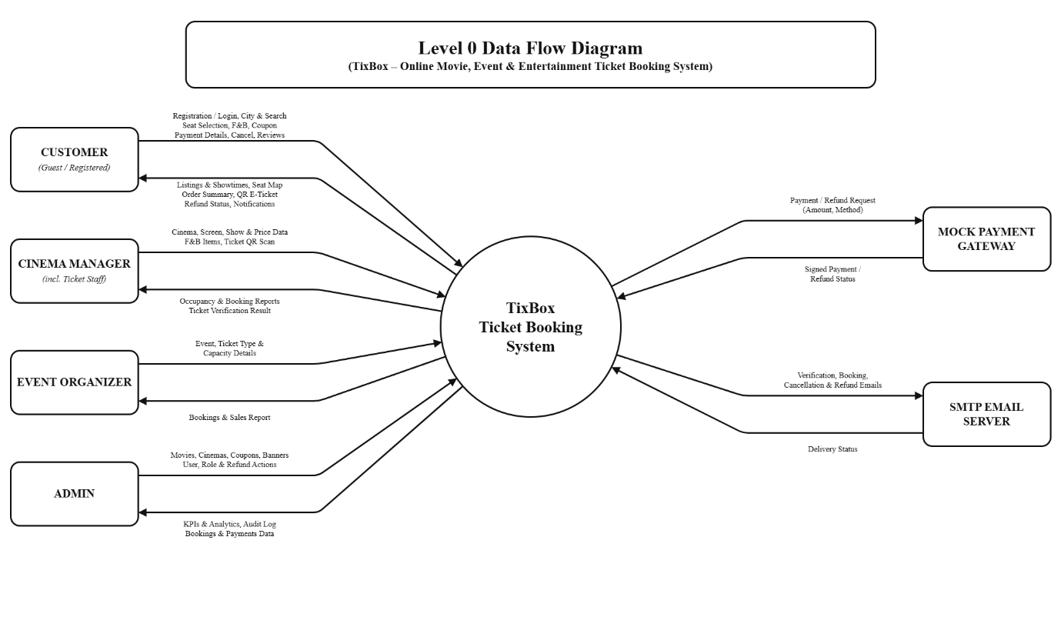

Figure 1: DFD Level 0 – IMovies

DFD Level 1 – Major Processes:
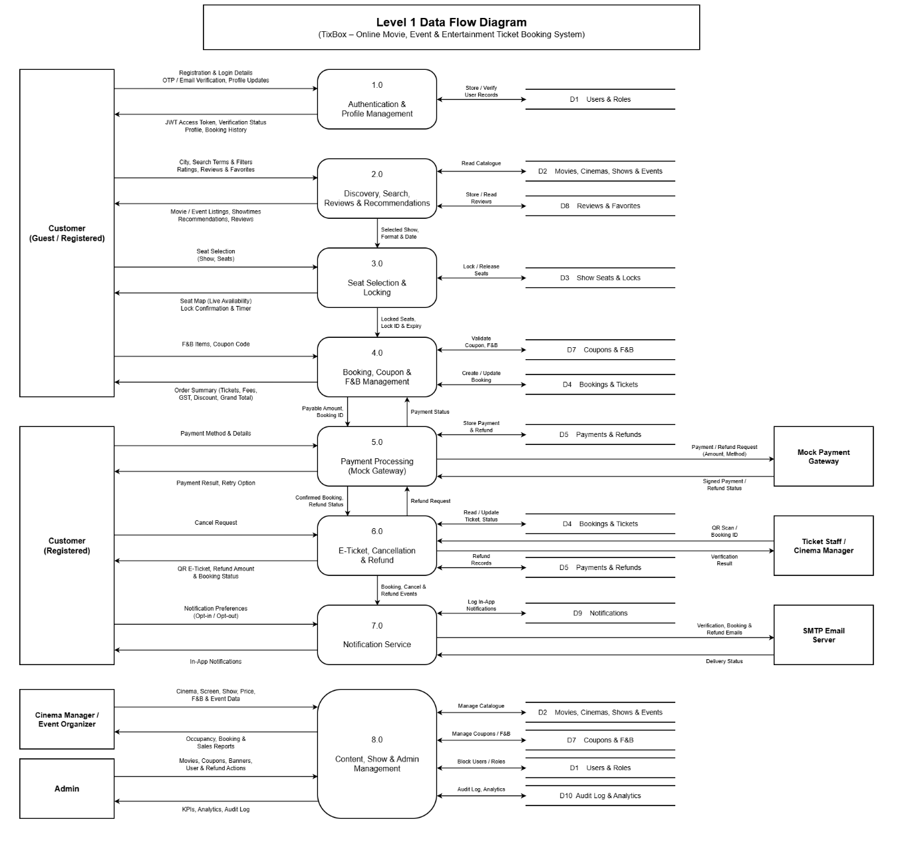
Figure 2: DFD Level 1 – IMovies (processes 1.0 to 10.0, data stores D1 to D9)
Level 1 Process Description:
No. | Process | Description | Data Stores
1.0 | Authentication & Profile | Registration, OTP/email verification, login, JWT issue, password reset, profile and RBAC | D1
2.0 | Discovery & Search | City selection, home sections, movie/cinema/event details, search, filter, sort | D2, D6
3.0 | Seat Selection & Locking | Seat map, atomic seat lock with 10-minute expiry, auto-release | D3
4.0 | Booking Management | Order summary with F&B, coupon, fees and tax; booking status handling | D3, D4, D7
5.0 | Payment Processing | Mock gateway initiate, verify, refund; signature check; server-side amount | D4, D5
6.0 | E-Ticket, Cancel & Refund | Signed QR ticket, staff verification, cancellation, refund slabs | D3, D4, D5
7.0 | Content Management | Movies, cinemas, screens, shows, events, F&B, coupons, banners | D2, D3, D6, D7
8.0 | Reviews & Recommendations | Ratings, reviews, favorites, personalised recommendations | D4, D8
9.0 | Notification Service | In-app notifications and asynchronous emails with retry | D9
10.0 | Admin & Analytics | KPIs, user management, reports, audit log | D1, D4, D5, D9
User Stories
User Story Table – IMovies
User Type | Functional Requirement (Epic) | User Story / Task | Acceptance Criteria | Priority | Release
Customer | Authentication | As a guest, I can register and verify my account by email or OTP so that I can book tickets. | Account is created; unverified users cannot book. | High | Sprint-1
Customer | Discovery | As a customer, I can select my city and search or filter movies and events. | Results match city, language, genre and format filters. | High | Sprint-1
Customer | Seat Selection | As a customer, I can pick seats on a live seat map and hold them temporarily. | Seats are locked for 10 minutes with a countdown; no double booking. | High | Sprint-2
Customer | Booking | As a customer, I can add F&B and a coupon and see a full order summary. | Total shows tickets, fee, GST, F&B, discount and grand total. | High | Sprint-2
Customer | Payment | As a customer, I can pay using the mock gateway (UPI, card, net banking, wallet). | Success confirms the booking; failure releases the seats. | High | Sprint-2
Customer | E-Ticket | As a customer, I can get a QR e-ticket and download it as PDF. | QR ticket appears in My Bookings and is emailed. | High | Sprint-2
Customer | Cancellation | As a customer, I can cancel a booking before the deadline and see my refund. | Refund breakup is shown; booking becomes Cancelled then Refunded. | Medium | Sprint-3
Cinema Manager | Content Management | As a cinema manager, I can create shows and set ticket prices for my cinema. | Overlapping shows are rejected; shows appear to customers. | High | Sprint-1
Cinema Manager | Ticket Verification | As ticket staff, I can scan a QR code to verify a ticket. | Valid ticket is accepted once; reuse is rejected. | Medium | Sprint-3
Event Organizer | Events | As an organizer, I can publish an event with ticket categories and capacity. | Event is listed; sold tickets never exceed capacity. | Medium | Sprint-3
Customer | Reviews | As a customer, I can rate and review a movie I booked. | Review appears with updated average rating. | Medium | Sprint-3
Admin | Administration | As an admin, I can manage users, coupons and view analytics and the audit log. | Actions are logged; dashboard shows KPIs and charts. | High | Sprint-3

